The following discrepancies in the Daily Progress Report (DPR) generated via T-Code ZPRA_Reports
- Graph Plot Error: The following errors are:
  - Annual Figures: The "Actual" values for BOPD, MMSCMD, and BOEPD do not align with the figures in the master DPR sheet.
  - YTD Column: The BOPD figures are mismatched; MMSCMD and BOEPD values are currently displaying incorrect data points.
  - The row for BE target for these values is correct.
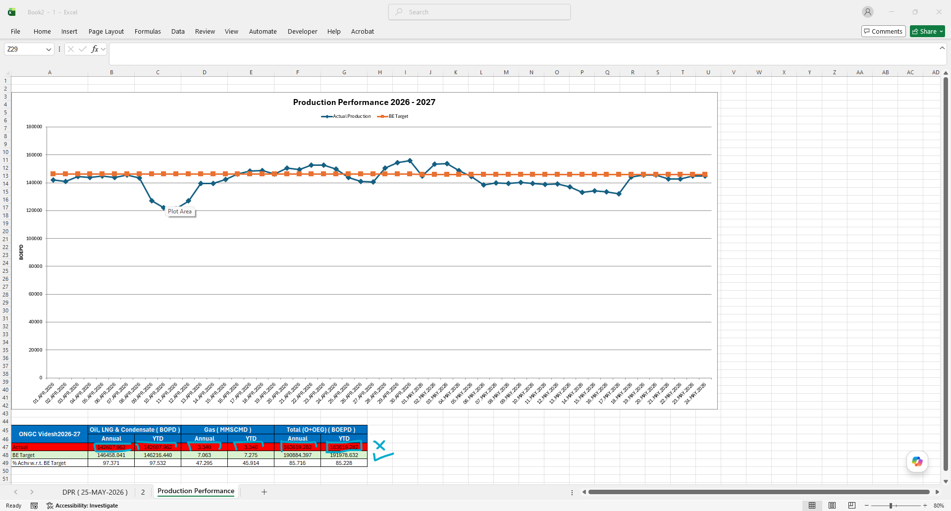
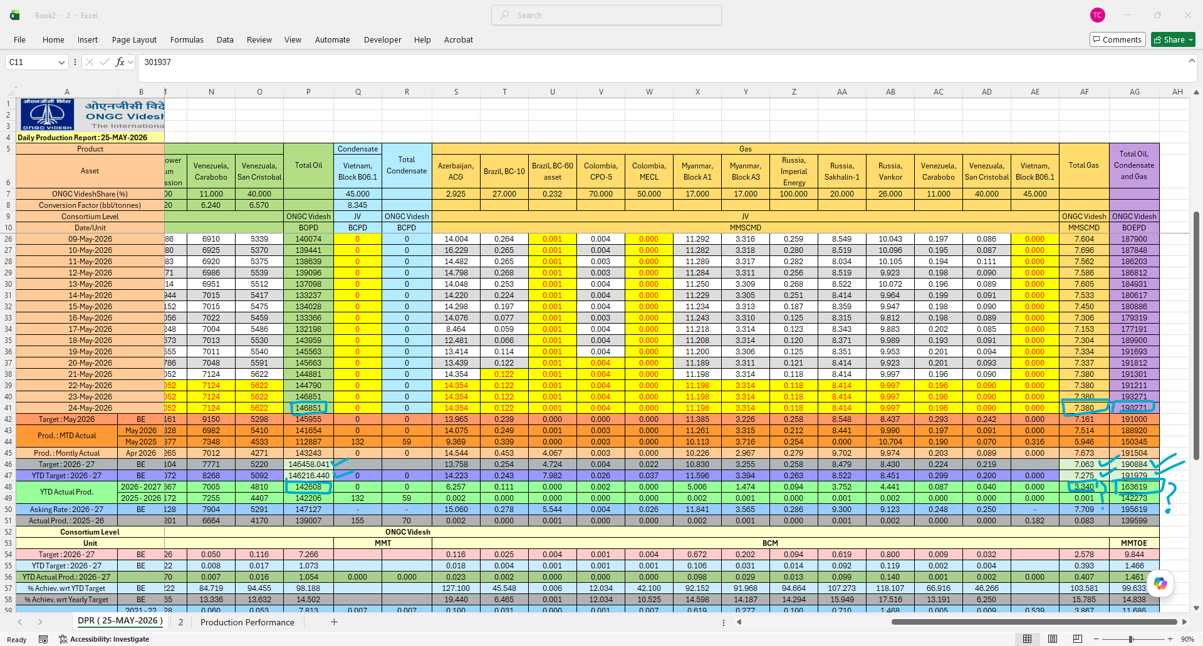

  - Graph is incorrect as it should be plotted for BOPED values (as mentioned in y axis) vs date.
Please reconfigure the plot to accurately display BOEPD values against the corresponding dates on the Y-axis.
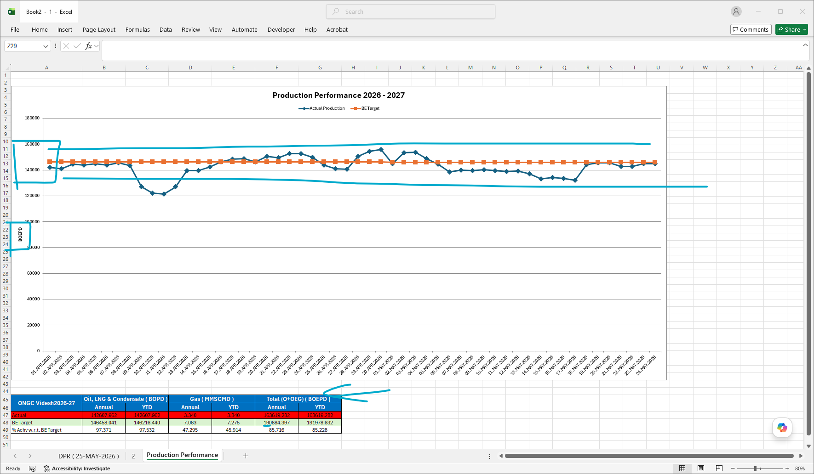

- Production Data Mismatch (Block 6.1): For Project Block 6.1, the total O+OEG production for FY 2025-26 is reflected incorrectly in the DPR. The accurate data is available in the Reconciled Production reports, as referenced below

